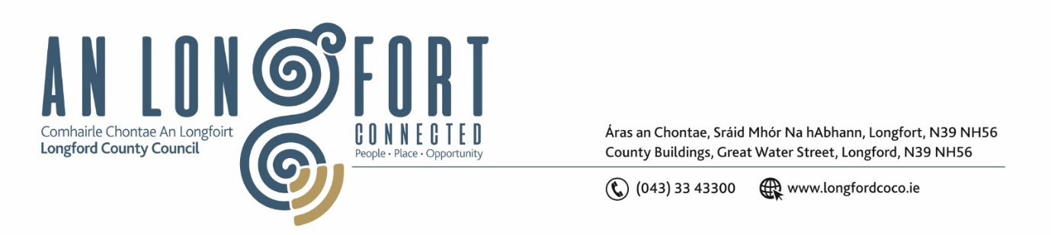

**LONGFORD MUNICIPAL DISTRICT**

**Minutes of Meeting of Longford Municipal District held via MS Teams**

**on Wednesday, 26th May 2021 at 4.30 p.m.**

**CATHAOIRLEACH**: Councillor Peggy Nolan

**MEMBERS PRESENT**: Councillors – Seamus Butler, Martin Monaghan,

John Browne, Uruemu Adejinmi, Gerry Warnock,

Gerry Hagan

**IN ATTENDANCE**: Mr. John Brannigan, Director of Services.

Mr. Eamonn Bennett, Senior Executive Engineer.

Ms. Lorraine Mc Kee, Administrative Officer.

**MEETINGS**

**ADMINISTRATOR:**  Ms. Ann Marie Mc Keon

**ADOPTION OF MINUTES – circulated.**

On the proposal of Councillor Gerry Hagan seconded by Councillor Seamus Butler, it was unanimously agreed to adopt Minutes of Longford Municipal District Meeting held on the 28th April 2021.

On the proposal of Councillor Uruemu Adejinmi seconded by Councillor Seamus Butler, it was unanimously agreed to adopt Committee Minutes of Longford Municipal District Meeting held on the 7th May 2021.

**MATTERS ARISING FROM MINUTES.**

R198 Water Burst

Councillor John Browne requested that the council follow up with Irish Water in relation to the full replacement of the water main on the R198 which burst again last week.

John Brannigan will raise the issue at the next Irish Water meeting.

Leader Park

Councillor Seamus Butler looked for an update in relation to the taking in charge of Leader Park. John Brannigan noted the Planning Regulations and that a road was required to be at a certain standard in order to be taken in charge and Longford County Council are currently looking at a proposal to secure the funding to bring this road to that standard for taking in charge.

Local Improvement Scheme

Councillor Gerry Warnock asked for confirmation that a road that is constructed under the Local Improvement Scheme could not be taken in charge. John Brannigan confirmed that this was correct.

**DECLARATION OF INTEREST BY MEMBERS.**

None.

**MANAGEMENT REPORT INCORPORATING AREA ENGINEER’S PROGRESS REPORT**

The Management Report, as circulated, was noted. Eamonn highlighted the following works and responded to questions raised by the members:

* Market Square
* N63 Major Wells Road
* Teffia Park Footpaths
* Newtownforbes Streets
* Town Jetting
* Drainage

**REGENERATION OF CAMLIN QUARTER UPDATE**.

Terry Rooney briefed the members on the current projects being undertaken by Regeneration.

* Longford Connected
* Camlin Quarter Regeneration
* Breadens Lane Towns and Villages Scheme
* Royal Canal Gateway Spur and Greenway
* Mall Complex
* Ballyminnion and Mastertech
* **MSWP** – in from N5, through Ballyminion and connecting with N63 **Active Travel** project, in turn connects to **Royal Canal Greenway** (purple Dash)
* **Royal Canal Gateway Spur** (green Dash) destination towns project connecting RCG with town centre
* **Longford Connected** (red) stepping stones from south to north through town, also **Urbsecurity/Breaden’s lane** (orange dash)
* **Camlin Quarter** (blue) series of projects using River as a Spine west-east
* **Platforms for Growth** (pink)
* **Mall Complex** (yellow)

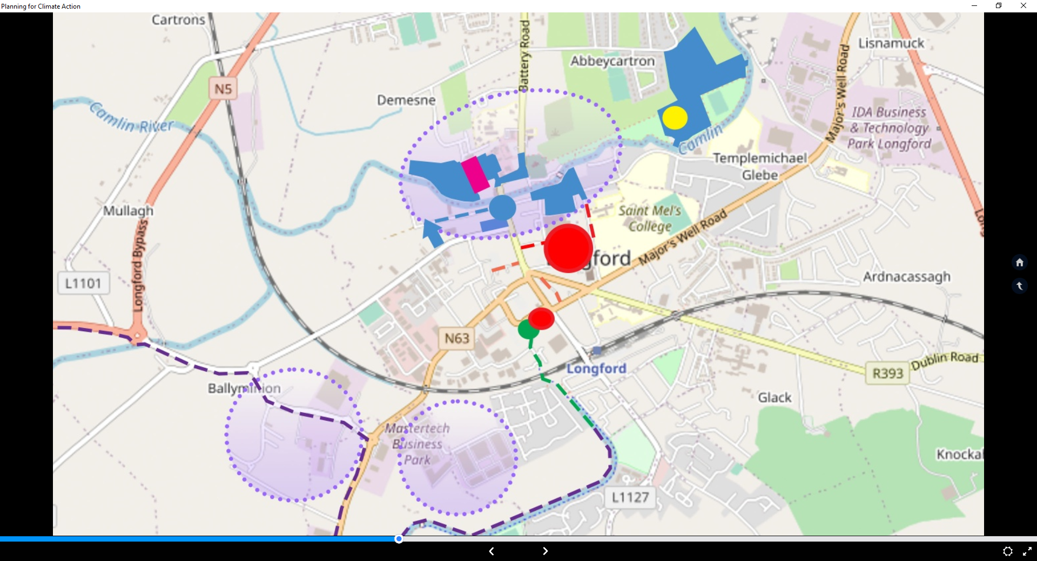

**Camlin Quarter**

* €14 million investment
* Awaiting Letter of Offer from the Department
* Civic Area - New Corporate Building/Public Services Centre
* Sequencing of projects and detailed design

**Delivery**

**Longford Connected**

* Commence construction July 2021
* Completed January 2022

**Royal Canal Gateway Spur**

* Commence construction November 2021
* Completed April 2022

**Camlin Quarter**

* Consultants appointed December 2021
* Commence pipeline of projects - 2022

The members asked the following questions which Terry replied to: -

* Connolly Barracks Site
* New site at Albert Reynolds Park
* Construction works on St. Mel’s Road
* Opportunities to look at Active Travel on Main Street/Ballymahon Street
* Off streetcar parking
* What is next when expressions of interest for Camlin Quarter looked at
* Timelines for projects
* Providers building

**CCTV UPDATE – PRESENTATION BY DANNY LYNCH**.

Danny Lynch gave an update on the CCTV in Longford town and responded to questions raised by the members – time frame for moving of mast – security of site.

**Tender Complete**

* Award made in December to Educom
* Total cost for phase one and two including stage 2 pole works of approximately 203,000 ex vat. Excludes cost of moving the mast.

**Update on Submission of application form for authorisation to operate a CCTV System under Section 38 (3)(C), Garda Síochana Act 2005 – Stage 2**

* Applications made and currently with Commissioner of An Garda Síochana for consideration.
* Local AGS have been advised that the application is with An Garda Siochana Date Protection Officer for consideration, an update on the application is expected by summer.

**Application for Funding**

* Funding for Phase 1 has been approved (45,000)
* Phase 2 stage application (45000) pending approval of stage 2 camera locations

**Connolly Barracks Mast Move**

* Work on Phase 1 of the project (update of existing) will commence once the mast move is complete. This work is been undertaken by the regeneration section

**Consideration of Adoption of Part 8 No. 85 change of use from Healthcare facility to**

**Residential dwelling at Newtownforbes, Co. Longford. Report in accordance with**

**Section 179 of the Planning and Development Act 2000 (as amended) and Part 8 of the**

**Planning and Development Regulations 2001 (as amended) – as circulated.**

Item deferred pending further information.

**LONGFORD BACK IN BUSINESS (PARKING CONCESSIONS).**

John Brannigan noted that there are quarterly parking permits available for workers which costs €85 per quarter. The permits reduce the daily cost of parking in an all-day carpark by €140 per annum. Parking permits are issued for all day carparks only, so for someone working in the Longford Centre, the closest all-day car park is St. Mel's road car park. They are not issued for the shopping centre carpark as this is a short-term carpark. John Brannigan will discuss the implications of free off streetcar parking for the month of June with the head of finance and will revert to the members within 24 hours.

Longford County Council are currently reviewing the byelaws and are working with the

hospitality sector to accommodate additional outdoor dining areas in public spaces.

The members unanimously supported free off streetcar parking for the month of June

and they requested a review of the parking spaces on Main Street, Ballymahon Street

and New Street.

**NOTICES OF MOTIONS**

Footpaths Red Cow roundabout

The following Notice of Motion was proposed by Councillor Martin Monaghan and seconded by Councillor Seamus Butler

That Longford County Council look at putting a footpath/walkway between the Red Cow Roundabout & the Charlotte Brooke Roundabout even if we have to utilise the old road that exists.

**Reply**

The project involves installation of 1000m of footpath including public lighting linking the old N4 with the bypass. A way leave may need to be obtained for a short section linking the new N5 bypass to the old N4. This project will require funding of at least €250,000.00. Longford County Council could consider this scheme for an active travel funding application in due course

Unfinished Units

The following Notice of Motion was proposed by Councillor Martin Monaghan and seconded by Councillor Uruemu Adejinmi.

That Longford County Council write to the owners of the unfinished units situated in the Mastertech Business Park to secure these units properly as they currently pose a health & safety risk.

**Reply**

Longford County Council have issued a Notice of Intention under Section 8(2) of the Derelict Sites Act to the owner of the unit at Mastertech Business Park, Farranyoogan, Longford.

Lough Forbes water treatment plant

The following Notice of Motion was proposed by Councillor Martin Monaghan and seconded by Councillor Peggy Nolan.

That houses that were previously connected to the Lough Forbes water treatment plant and have been switched to the Lanesboro treatment plant be put back to Lough Forbes treatment plant as soon as possible and that the works on Lough Forbes be expedited to solve the ongoing issues that have occurred with this switch.

**Reply**

Longford County Council received a response from the relevant department advising that the water produced at Lanesborough is sampled and analysed in accordance with the Drinking Water Regulations and found to be of a high quality. It is also worth noting that any project to amend the treatment process at Lanesborough, would be very costly and likely take over 3 years to complete. It is envisaged that the Lough Forbes work will be completed by Dec 2021 / Jan 2022 at which point Clondra should be supplied by Lough Forbes again. These works cannot be expedited any further. Longford County Council will write to Irish Water to express the members concerns.

Safety at Carton Breac

The following Notice of Motion was proposed by Councillor John Browne and seconded by Councillor Peggy Nolan.

“In the interest of safety, I call on Longford County Council to have a speed ramp put in place opposite the children’s play area at Cartron Breac, Longford”.

**Reply**

Longford County Council will carry out speed surveys at this location. If a speeding issue is confirmed, Longford County Council will notify the Gardai who are responsible for enforcement of the speed limits. In addition, Longford County Council will review this location to determine if any measures can be put in place to reduce speeds. Should there be an appropriate treatment, Longford County Council will apply for funding under Low cost Safety Scheme.

Derelict Notice Killoe

I call on Longford Municipal District to Serve a Dereliction notice order on the abandoned /derelict house at No 5 An Croissaire, Killoe in the interest of public safety.

Councillor Gerry Hagan has requested that this be forwarded as a Notice of Motion for the June Meeting of Longford County Council as this property is not in the Longford Municipal District.

Traffic Lights Main Street

The following Notice of Motion was proposed by Councillor Gerry Hagan and seconded by Councillor Martin Monaghan.

That Longford MD will carry out an evaluation on the traffic lights on Main Street, Longford at the junction at Richmond Street to facilitate more free flow of traffic through the junction and decrease delay time on traffic.

**The members requested an update for the next meeting.**

**Reply**

This notice of motion has been referred to the Senior Executive Engineer in the road design office to carry out a review of the traffic lights at the junction of Main Street and Richmond Street.

Michael Neary Park

The following Notice of Motion was proposed by Councillor Seamus Butler and seconded by Councillor Uruemu Adejinmi,

‘That Longford Municipal District review the terms and conditions regarding Michael Neary Park’

**Reply**

Longford County Council are currently reviewing the terms of the lease on Michael Neary Park.

Picnic Table

The following Notice of Motion was proposed by Councillor Uruemu Adejinmi and seconded by Councillor Peggy Nolan.

Inclusive public spaces allow for a healthy public life where social interactions can occur in all outdoor spaces and around public facilities. All our public spaces should seek to unite the entire community and support opportunities for individual well-being and promote equitable, healthy and committed communities.

I am therefore calling on Longford County Council to roll out wheelchair accessible picnic tables in public spaces in the Municipal District to make our public spaces in Longford more inclusive.

A sample of such picnic table is below and a member of the disability group in Longford is keen for this to be implemented and has put in an early request that the edges of the tables be curved and not sharp.

**Reply**

When Longford County Council are providing and or replacing picnic benches, we will use wheelchair accessible ones where feasible.

Councillor Seamus Butler requested that notification of this adopted motion be forwarded to members of the other Municipal Districts.

Retirement of Mark Mc Nerney

The members wished Mark Mc Nerney health and happiness in his retirement after 44 years of service with Longford County Council.

Cathaoirleach Peggy Nolan

The members thanked Cathaoirleach Peggy Nolan for her outstanding service as Cathaoirleach of Longford Municipal District and all the Members joined in wishing Councillor Nolan every success during her term of Cathaoirleach of Longford County Council.

Sympathy

Councillor Uruemu Adejinmi expressed her sympathy to the Mc Donagh Family, Ardnacassa on the death of their son following a tragic accident.

This concluded the business of the meeting.

**Ann Marie Mc Keon**

**Signed: ____________________**

**Ann Marie Mc Keon**

**Meetings Administrator.**

**Confirmed and adopted at Longford Municipal District Meeting held on the 23rd June 2021.**

**Peggy Nolan**

**Signed: _______________**

**Cathaoirleach.**